**Neumann.Berlin and music producer Eric J. Dubowsky: An award-winning partnership**

***ARIA and Grammy award winning mix engineer and producer, Eric J. Dubowsky, charts his enduring relationship with Sennheiser and Neumann while discussing his work with Flume, Sabrina Carpenter, Dua Lipa, Chemical Brothers and Weezer.***

***Brussels, January 7, 2025 – Eric J. Dubowsky, an award-winning mixer, producer and engineer has built a successful career through his passion for music and the technology that helps capture it. He sat down with Sennheiser to discuss his very first Neumann U 87 microphone, his recent love of Sennheiser’s HD 490 PRO headphones – and the dozens of artists he’s worked with in between.***

***\*\*\*Video\*\*\****

***Link :*** [***An Award-Winning Partnership: Who is Eric J? | Sennheiser***](https://www.youtube.com/watch?v=CaGzbgZusNk&t=1s#_cb1733952709)

**Career beginnings at NYC’s iconic Greene St. Recording**

Dubowsky’s journey into the recording industry began with an early love of music, fostered by a family of musicians and a constant exposure to sound. Although an accomplished musician in high school and college, it was the art of capturing sound that ignited a lifelong passion of studio recording for Dubowsky.

He began his career at Greene St. Recording in New York City, an iconic studio that was pivotal in shaping the sound of hip-hop and electro in the 80s and 90s. It was here, working alongside producers including Rod Hui (Run-D.M.C and Public Enemy), Nick Sansano (Sonic Youth), and John Robie (Afrikaa Bambaataa) that Dubowsky developed his foundational understanding of audio engineering. “It’s about the low end,” he recalls. “Drums and bass that hit hard – a principle that translates across every genre I’ve worked on.”

From these early days, Neumann microphones became synonymous with his work. “The first real mic I bought was a Neumann U 87,” he says, reflecting on how this iconic piece of gear made him feel like a true professional. To Dubowsky, Neumann is inseparable from the history of recording, embodying both the timeless and the contemporary. “They give me character when I need it and transparency when I don’t,” he explains.

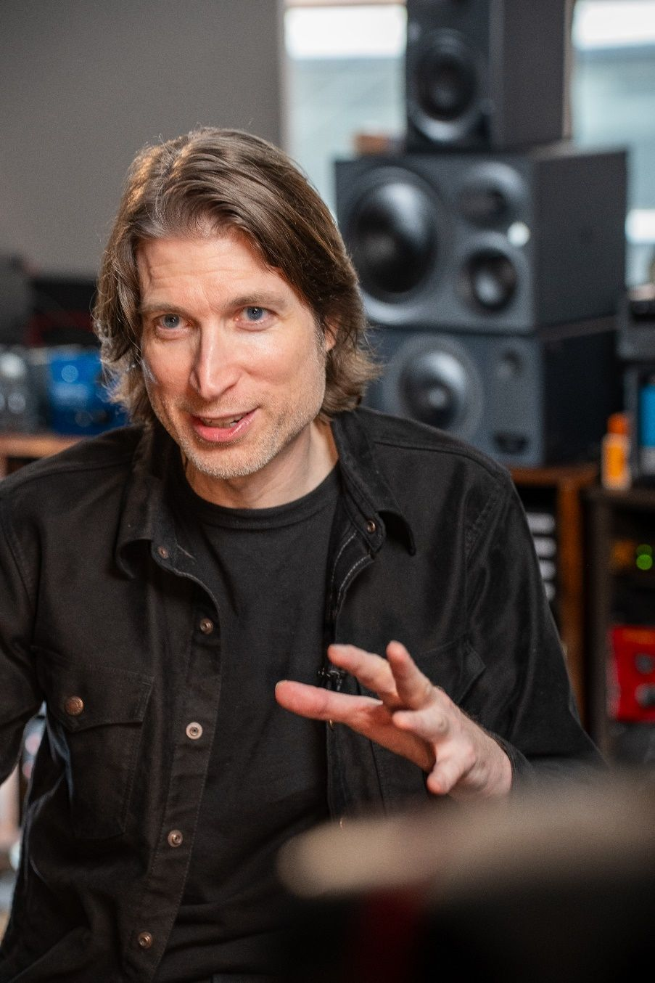

**A reliance on Neumann microphones**

Reliability is a cornerstone of Dubowsky’s choice in gear. “I don’t have time for equipment that doesn’t work perfectly,” he says, emphasising Neumann’s reputation for consistency. “It’s all about sound quality. Their microphones don’t just reproduce sound—they bring it to life.”

Over the years, Dubowsky has applied Neumann’s iconic sound to a diverse array of artists. On projects like the Teskey Brothers’ ARIA-winning *The Winding Way,* Dubowsky collaborated with engineer Wayne Connolly, again relying heavily on Neumann mics. “The U 67 was essential for capturing that timeless warmth,” he says. He also notes how the KM 86, once relied on by Motown, remains a favourite for its versatility and was the cornerstone of the drum sound for this record.

Similarly, while working with Weezer in the early 2000s, Dubowsky explored innovative recording techniques, using microphone combinations featuring the U 67 for unique sonic layers.

Dubowsky’s work spans multiple genres and continents, requiring adaptability across varying studio environments, from Skrillex’s space in LA to intimate setups on a laptop in a café. Through it all, Neumann and Sennheiser have been constant allies.

**A workflow transformed via Sennheiser**

Alongside his arsenal of Neumann's KM 86, U 47, U 67, U 87 microphones, Dubowsky also leans on Sennheiser’s HD490 headphones, and KH 310 monitors. Combined, these tools have transformed his workflow, allowing him to experiment with textures, depths, and atmospheres, while achieving perfect vocal placement.

Dubowsky recently integrated the KH 310 monitors into his workflow. “The monitors offer a natural sound that’s both accurate and non-fatiguing,” he explains. Their precision has been instrumental in fine-tuning mixes for artists across genres, from rock ballads to dense electronic tracks. “They essentially give me a magnifying glass into the mix,” he shares. ​

As a traveling mix engineer, portability and reliability have become non-negotiable. “The HD 490 headphones are a game-changer,” Dubowsky remarks. “They let me work on detailed mixes anywhere, from hotel rooms to cafés, without sacrificing quality.”

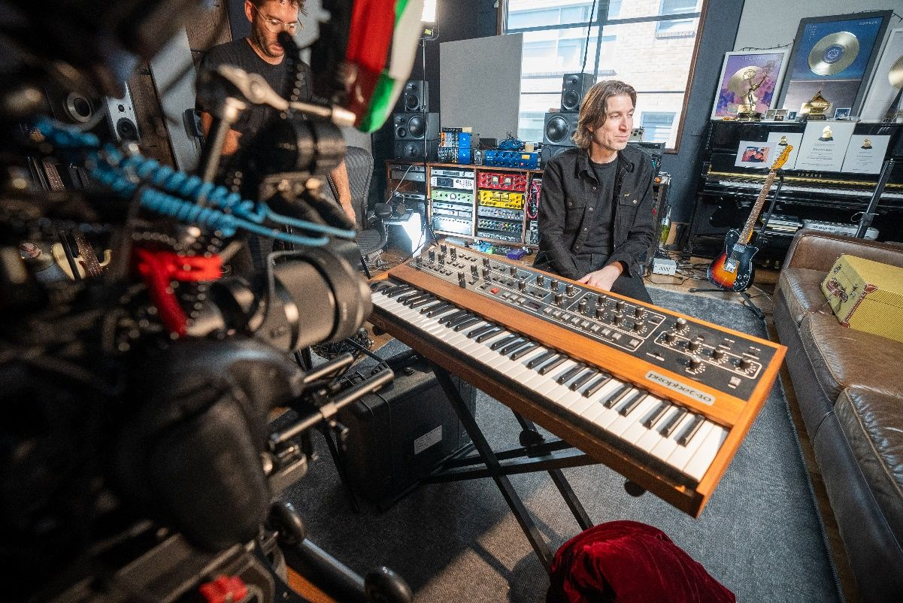

*Eric in the studio with Sennheiser and Neumann gear*

**Award winning advice**

Even after decades in the industry, Dubowsky’s love for music remains as strong as ever. “I feel lucky to work on music every day,” he says. For him, it’s about creating an emotional connection between the artist and the listener. This ethos drives his ability to balance critical acclaim with commercial appeal. “From winning the Grammy with Flume, to helping emerging artists translate what’s in their heart and capture it for the benefit of listeners, doing what I do is a dream come true,” Dubowsky notes.

Dubowsky’s career is marked by numerous accolades, including a Neumann sponsored Music Producers and Engineers Award (MPEG) for Producer of the Year and most recently an ARIA nomination.

Reflecting on his journey, Dubowsky emphasises the importance of trusted gear: “Awards are great, but they’re the result of consistent work and the right tools. Neumann has always been part of that equation.”

Dubowsky has a clear message for those starting their careers: “Invest in gear that lasts and grows with you.”

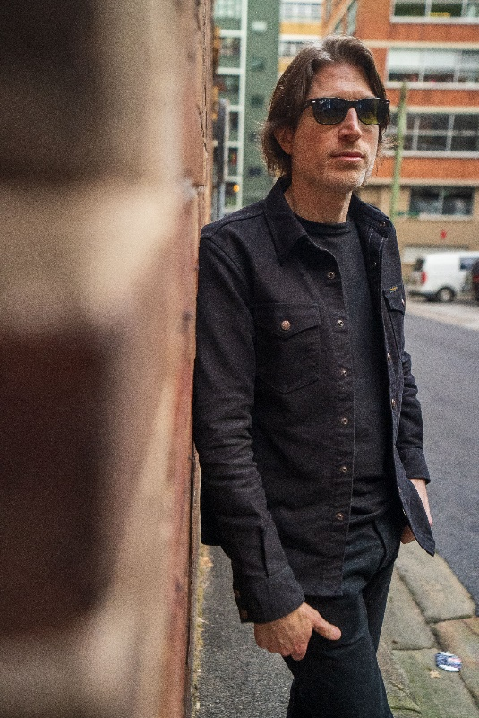

*Eric posed near the studio*

**Looking to the future**

Dubowsky has helped shape some of the defining sounds in recent recording history and as he looks to the future, he’s excited to explore more collaborations that push sonic boundaries.

Dubowsky’s journey is a testament to the power of passion, adaptability, and reliable tools. From his formative years at Greene St. Recording to his award-winning work with global artists, Neumann microphones have been more than gear—they’ve been an enabler of creativity and excellence. As Eric himself says, “music is magic, which keeps me curious and intrigued to explore - what's next. And, as for the future, there’s a lot coming next year that I can’t wait for people to hear. My hope is that these sounds continue to excite people, that they might feel emotionally invested in the journey too."

[ends]

**About Sennheiser Group**

Building the future of audio and creating unique sound experiences for our customers - this is the aspiration that unites the employees of the Sennheiser Group worldwide. The independent family-owned company Sennheiser was founded in 1945. Today, it is managed in the third generation by Dr. Andreas Sennheiser and Daniel Sennheiser, and is one of the leading manufacturers in the field of professional audio technology.

[sennheiser.com](https://protect-eu.mimecast.com/s/lUszCgxgJHAZzmKWSo3cGI?domain=sennheiser.com) | [neumann.com](https://protect-eu.mimecast.com/s/hW3dCm2oZUjNQA8YSDwLrJ?domain=neumann.com) | dear-reality.com | [merging.com](https://www.merging.com/)